Directions to University Hospital of Wales
Medical Centre Sports and Social Club
President’s Room, 25th September 2010 at 2pm

By car
- From England, follow the M4, and turn off at junction 29.
- Follow the A48M / A48 to Cardiff centre / Bridgend, for approx. 5 miles.
- ***About 1½ miles after the junction with the A4161, take the slip road to the
University Hospital of Wales.
- After crossing over the A48, use the multi-storey car-park on your left, and park on level 3.

From the west, it is probably easiest to continue on the M4 to junction 30, then turn right onto the A4232. After a mile turn right again onto the A48, and follow from *** above.
The slip road is about 3½ miles after you join the A48.

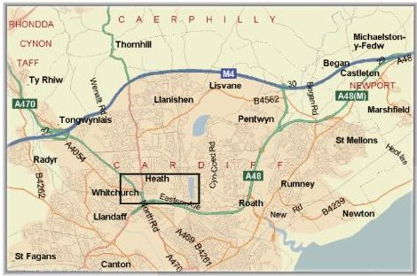

After swapping your ticket (see below), leave the multi-storey car-park by the main pedestrian entrance (to the north), cross over the pedestrian crossing, and the Sports and social club is on your right, where we are meeting

Take a ticket as you go in to Multi-Storey car park 9, and park on Level 3 only.
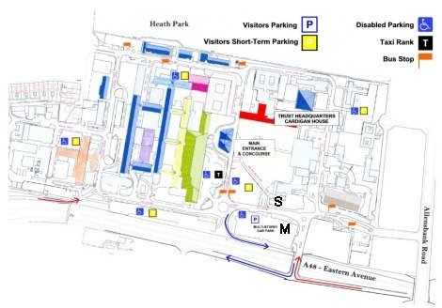
Make your way to the Parking Shop Office on the ground floor before you go to the AGM, and quote module VP872. The officer will swap the ticket from the entry barrier for a £3.00 staff ticket.

Enter from the
bottom right, by
the red arrow.

M is the multi-storey
car park

S is the Sports and
Social Club

By rail

High speed InterCity trains to Cardiff Central Station provide frequent services between all major British cities.

Cardiff Central Station is located adjacent to the bus station where there are frequent bus services to Heath Park campus. Buses 1, 2, 38 and 39 go to Heath Park.

A taxi rank is also located outside – a taxi is likely to cost around £6.00.

